**Project Design Phase-II**

**Technology Stack (Architecture & Stack)**

|  |  |
| --- | --- |
| Date | 03 October 2022 |
| Team ID | PNT2022TMID35886 |
| Project Name | Real Time Communication System for Specially-Abled |
| Maximum Marks | 4 Marks |

**Technical Architecture:**

**CNN**

**FLASK**

**DP**

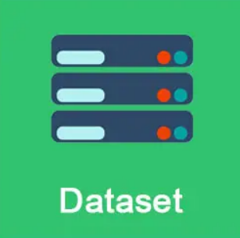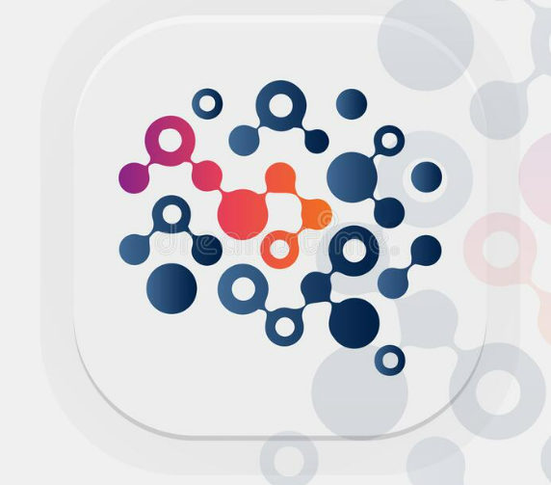 

TRAIN DATA

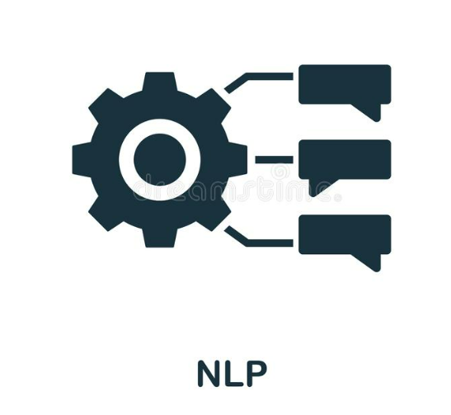

TEST DATA

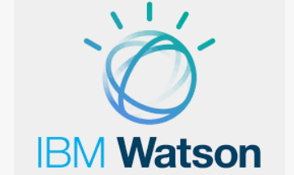 

**USER 1**

**Table-1: Components & Technologies:**

|  |  |  |  |
| --- | --- | --- | --- |
| **S. No** | **Component** | **Description** | **Technology** |
|  | User Interface | By using Web UI and Mobile app user interacts with the application | HTML, CSS, Python |
|  | Application Logic-1 | Getting the Hand Gesture Images dataset | Python |
|  | Application Logic-2 | Analysing the application and the representation of the hand gestures | IBM Watson, Python, CNN |
|  | Application Logic-3 | Getting audio as input data | IBM Watson, Python, CNN |
|  | Database | Data Type- Hand Gesture movements (Images)and their representations | MySQL, JavaScript, IBM DB2 |
|  | Cloud Database | Database Service on Cloud | IBM DB2, IBM Cloudant etc. |
|  | File Storage | Received hand gesture movements and the audio speech is stored in the cloud | IBM Block Storage, IBM cloud, Local Storage |
|  | CNN (Convolutional Neural Network) | Purpose of CNN is used for the understanding of sign to human readable language and vice-versa | CNN, Object detection model, NLP |
|  | Machine Learning Model | Purpose of AI-Machine Learning model is used for the identification of hand gestures recognition, Sign language and vice-versa | Object Recognition Model, CNN and NLP for voice data and hand gestures |
|  | Infrastructure (Server / Cloud) | We will be deploying the AI and CNN model using flask in the web application of cloud server | Python Flask |

**Table-2: Application Characteristics:**

| **S. No** | **Characteristics** | **Description** | **Technology** |
| --- | --- | --- | --- |
|  | Open-Source Frameworks | Open-Source framework used in IBM Watson | Technology of Opensource framework |
|  | Security Implementations | IBM cloud | e.g. SHA-256, Encryptions, IAM Controls, OWASP etc. |
|  | Scalable Architecture | Database server-On the basis of new applications acquiring from the user, the dataset can be modified accordingly.  Application Server-While updating of dataset takes the integration of the application as per user demands and requirements can be done. | IBM Watson Assistant, MySQL, Python |
|  | Availability | The AI and CNN model is available instantly when in need without any modifications process can be made | IBM Watson Cloud Assistant |
|  | Performance | IBM Watson and the Cloud is used to store data where the deep learning and NLP model is used for training of data (audio/hand gestures).  By using IBM Watson studio better performance and convenience. | IBM Watson Assistant, NLP |